Application documentation



Main Activity: The First Activity that start on Application start. It calls the Loading Activity, and when it's done, it calls the Guitar Activity.

Loading Activity: An Activity that contains an animation of the opening of the App.



Guitar Activity: The most important Activity of the App. contains the guitar playing part of the App.

Classes used by this Activity: AnimationClass, ActivitySwipeDetector, Cord, CordManager, PointerTouch).



Record: When pressing long on the recording button, a record is starting for all the user's strumming on the guitar.

Classes used by this Activity: PlayingGuitarBuffer, AudioFormat.

Record Player Activity: After done with the recording, the user is being asked if he wants to save a play his last recording. If he press "ok", he is starting this new activity, which contains a player that plays his last record.

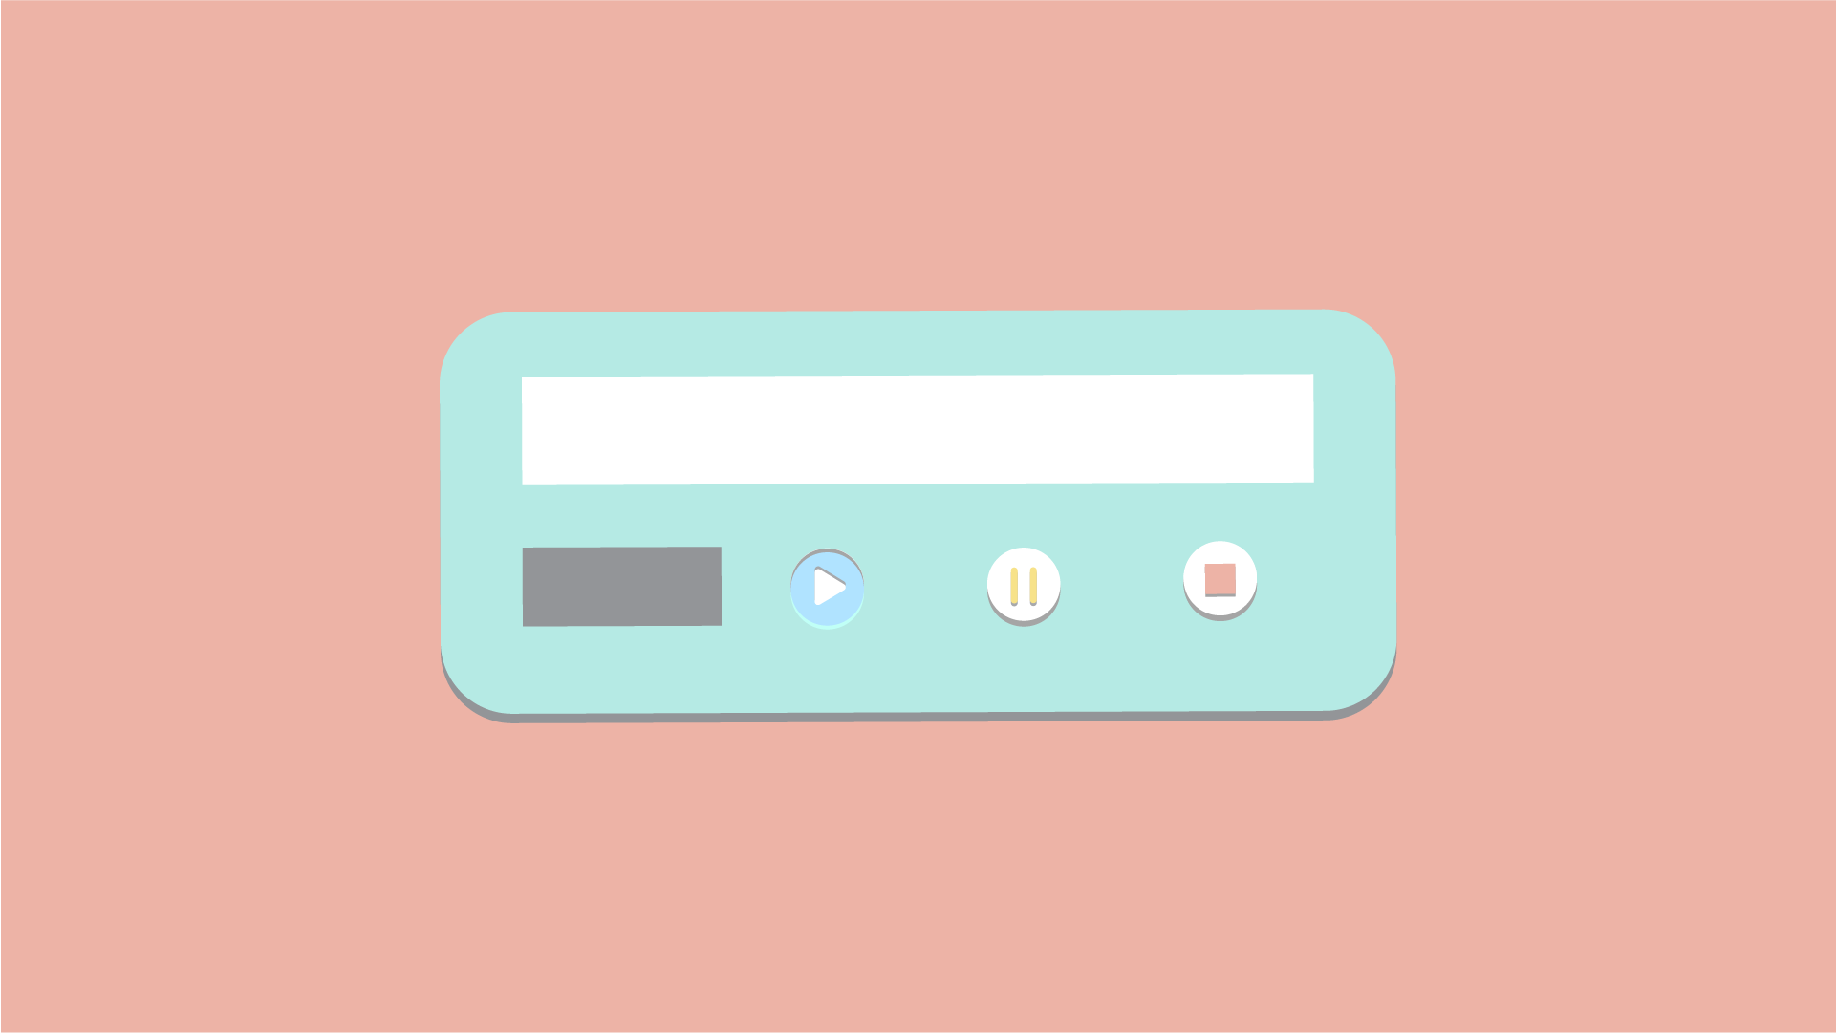

Menu Activity: When pressing long on the menu button, a new Activity with all the menu options is being started.

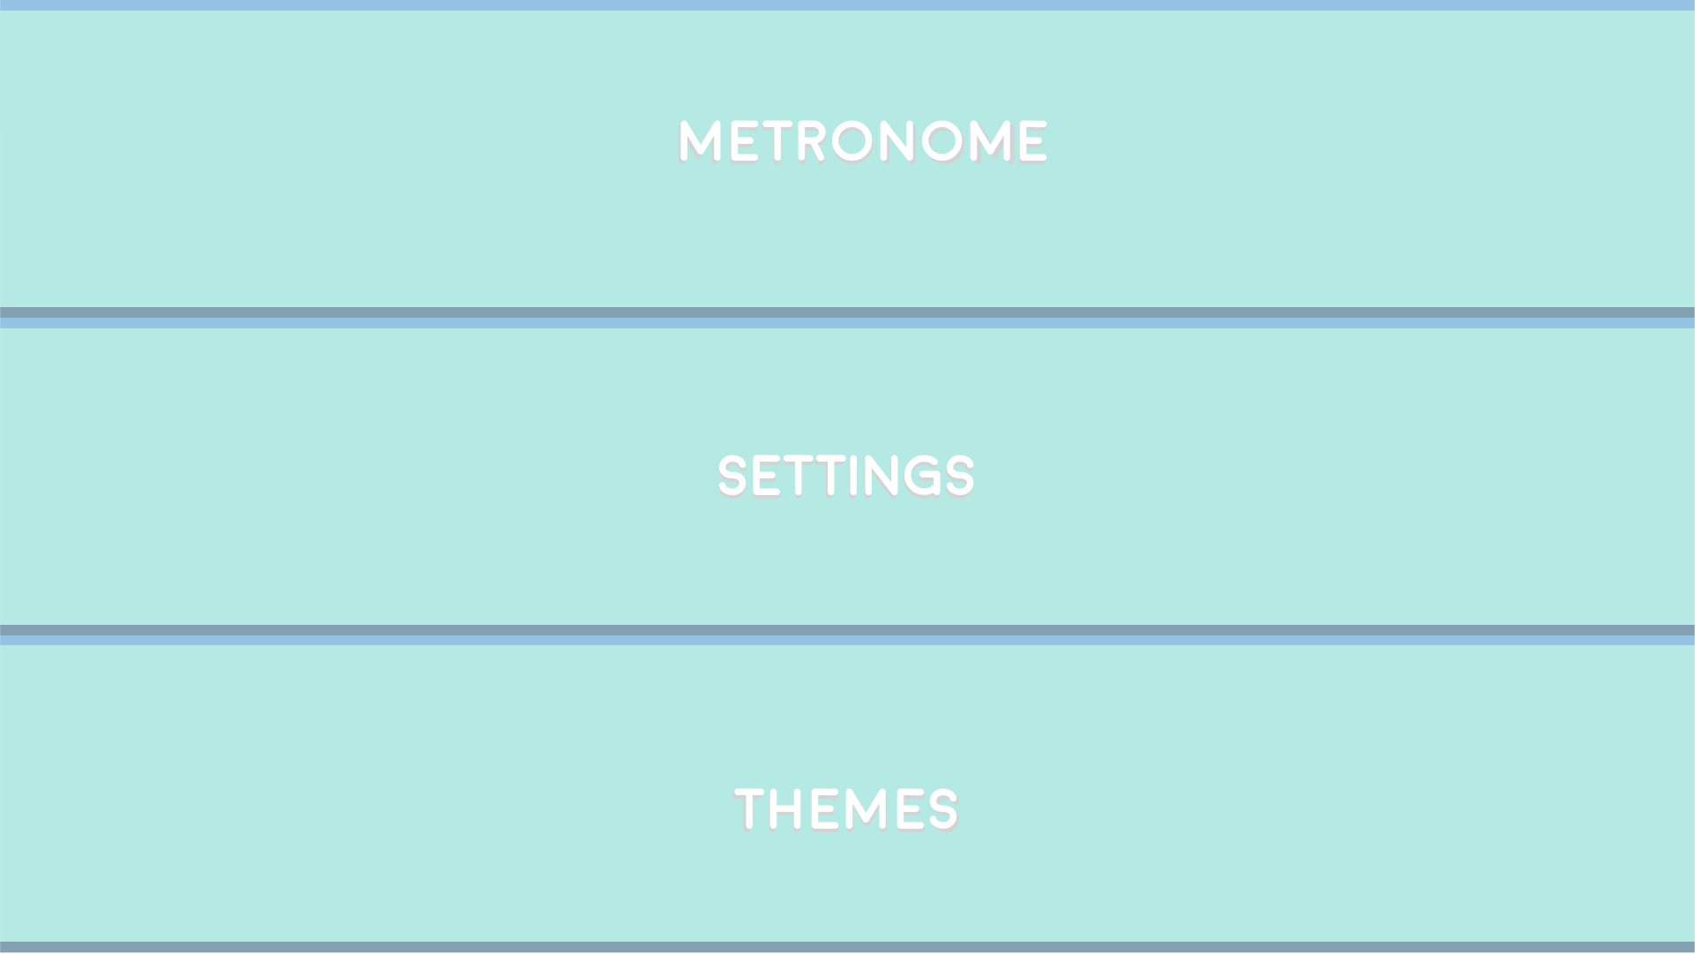

Metronome Activity: This activity is contains a player of metronome that is being played when pressed on the play button.

Classes used by this Activity: Metronome, AudioGenerator.

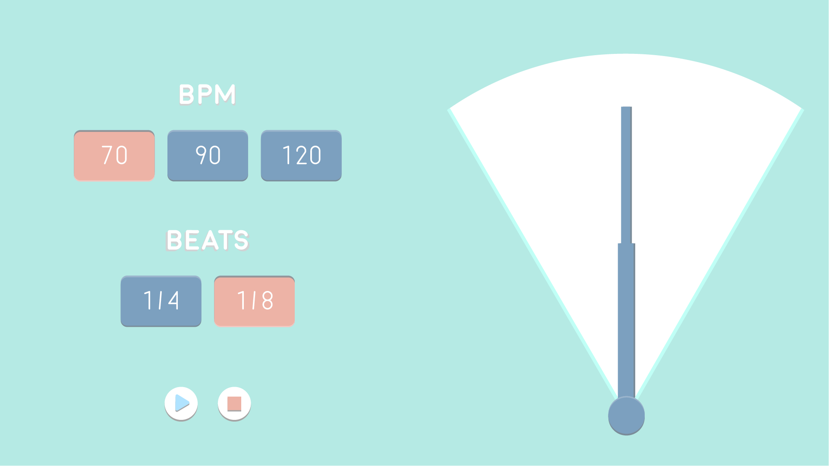

Setting Activity: This class represent the Setting Activity of the App. every setting option that has been chosen by the user is saved in the SharedPreferences Object.

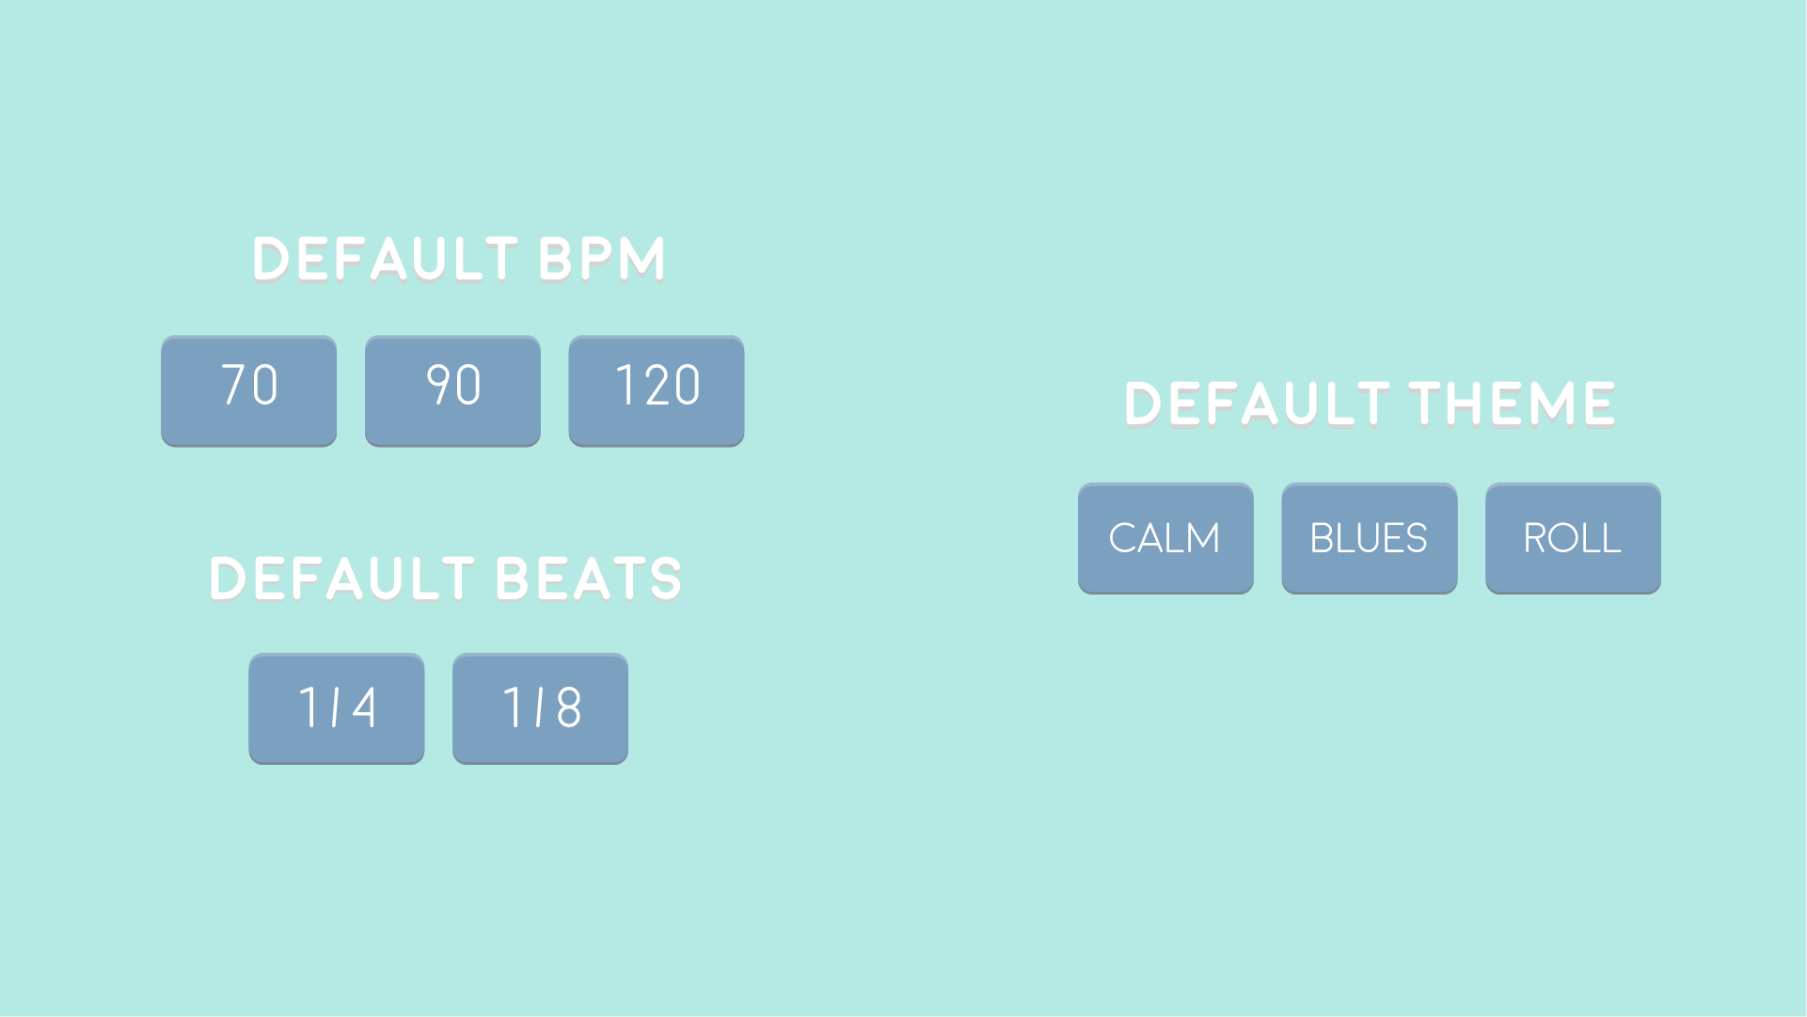

Choose Activity: This activity is used for the change theme menu in the app's menu.

